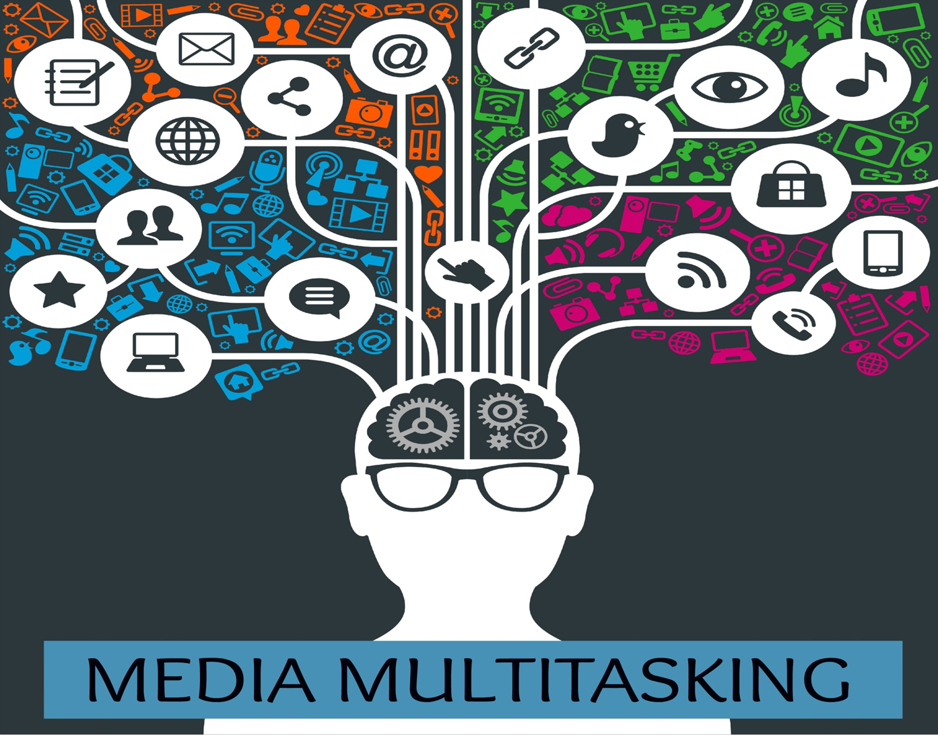

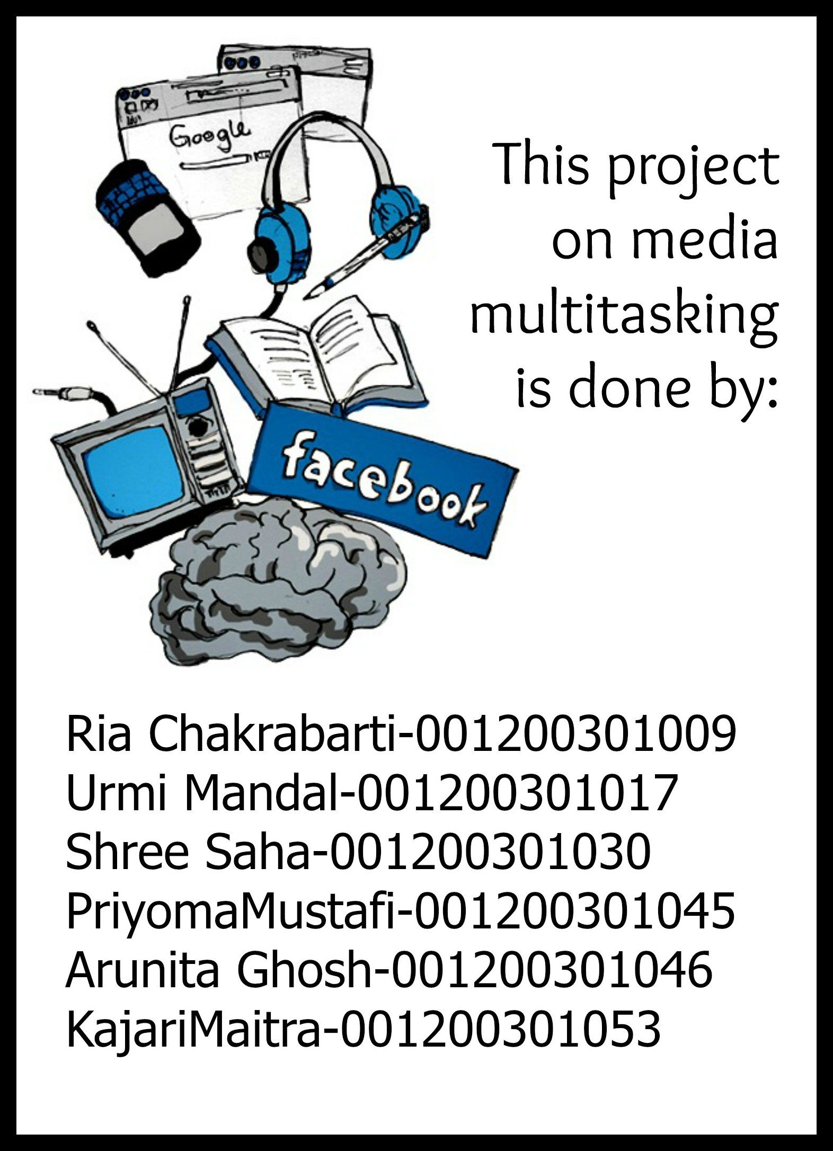

**Acknowledgement**

***First of all we must thank our project mentor Dr. Poulomi Roy, Jadavpur University,for giving us the necessary guidelines for our project through numerous consultations. We would also like to expand our deepest gratitude to all those professors who have taught us the basics of economics and statistics.***

***We also thank to all those people who have helped us by filling the questionnaire.In addition, our classmates and team members itself have made valuable comments and suggestion on this project. Thank you to all those people who have directly or indirectly contributed to this project.***

**Contents**

1. **Introduction.**
2. **Reasons behind multitasking.**
3. **Effects of Multitasking**

* **Ill effects of multitasking**
* **Advantages of multitasking**

1. **Choice of study**
2. **Literature review**
3. **Scope of study**
4. **Methodology**

* **The design of the questionnaire.**
* **Method of data collection**
* **Types of data**

1. **Observations**
2. **Regression**

* **Regression 1**
* **Regression 2**

1. **Variable sources**

* **Regression 1**
* **Regression 2**

1. **Multicollinearity.**
2. **Conclusion.**
3. **Policy prescriptions.**
4. **Problems faced.**
5. **Appendix.**

* **Other Regressions.**
* **An experiment.**

1. **Limitations.**
2. **Executive report.**
3. **References**

**List of figures**

* **Figure 1: Depicting use of cell phones while studying.**
* **Figure 2 : Depicting the gender share of all the respondents.**
* **Figure 3: Depicting the various age group and the percentage of respondents in each such groups.**
* **Figure 4: Depicting multitasking done according to respondents.**
* **Figure 5: Depicting use of cell phones by students while studying.**
* **Figure 6: Depicting watching of television while studying by students.**
* **Figure 7: depicting listening to music while studying by students.**
* **Figure 8: Depicting eating and watching television (together).**
* **Figure 9: Depicting whether according to the correspondent multitasking affects their health.**
* **Figure 10: Depicting respondents opinion whether multitasking should be allowed for students.**



**Our project deals with the effects of multitasking on students’ efficiency at work and on their health, aged between 20 to 22 years, both male and female. Before proceeding with our project, we have tried to envisage the meaning and purview of multitasking.**

**The term “multitasking” was coined from the computer engineering industry. It refers to the preparedness of a computer to process several tasks, concomitantly.**

**Human multitasking traces its roots to computer multitasking. Human multitasking is the accomplishment by an individual of handling two or more activities, concurrently. There are three major brackets of multitasker . Some people do it out of exigency and obligation, some others do it impulsively and the remaining do it amour-propre as they believe they are good at it.**

**Human multitasking may range from manual work like sweeping, cleaning utensils, washing clothes, walking, driving, childcare, cooking sports activities, etc, performing two or more of them at the same time, to media multitasking. Our project concerns broadly media multitasking.**

**Recent years have seen a fundamental shift in how individuals are choosing to use media. The most recent nationally representative surveys of the Pew Internet Project show how immersed teens and young adults are in the tech environment and how tied they are to the mobile and social sides of it. Some 95% of teens ages 12-17 are online, 76% use social networking sites, and 77% have cell phones. Moreover, 96% of those ages 18-29 are internet users, 84% use social networking sites, and 97% have cell phones. Over half of those in that age cohort have smart phones and 23% own tablet computers.**

**People are tuning in to communications technologies at an ever-expanding level. Some recent indicators:**

* **Nearly 20 million of the 225 million Twitter users follow 60 or more Twitter accounts and nearly 2 million follow more than 500 accounts.**
* **There are more than 800 million people now signed up for the social network Facebook; they spend 700 billion minutes using Facebook each month, and they install more than 20 million apps every day. Facebook users had uploaded more than 100 billion photos by mid-2011.**
* **YouTube users upload 60 hours of video per minute and they triggered more than 1 trillion playbacksin 2011 – roughly 140 video views per person on earth.**

**Multitasking behaviors can be understood in the context of their purpose and goals.  For example, if a student is using a computer to enter data while listening to music then these two activities can be done simultaneously. This is known as “dual tasking.”  Whenever we are engaged in any two tasks at precisely the same time, then simultaneous processing, or dual tasking, is taking place.**

**However, very often it is sequential processing that occupies our time.  For example, a student might be using a computer to write an essay, stop to send a text message, check Facebook, return to the essay for five minutes, then stop typing to read the return text message, etc. This type of switching among sequential tasks is referred to as “attention switching” because to effectively change tasks requires a change of attention and focus. Changing attention does allow us to switch among activities, butdifferent parts of the brain are involved in the actual performance of each task. It has been clinically  demonstrated that task and attention switching during sequentialprocessing can indeed result in effectively accomplishing multiple goals in the same general time period.    However, researchers have found that focusing on just one task involves fewer errors and requires less time to accomplish than trying to engage in multiple tasks.**

**Information that is intended to be remembered requires a deeper level of sustained attention to process than information that does not need to be stored in memory.  Sequential and simultaneous processing both interfere with our ability to sustain attention unless one of the tasks is very passive or requires little or no thought, such as listening to background music.  It is the level of processing during an activity that is most significant to our ability to store information.  The more cognitively difficult a task, such as**

**learning complex information, then the greater degree of attention it requires.**

**Media multitasking is most common in students.Constant use of technology may disrupt or interfere with their ability to sustain attention, which is the foundation of thought.  Attention is needed not only to learn, but to understand the world in which we live.  A challenge for students is to maintain focus and concentration.**

**In our project, we have tried to delve if such media multitasking is derogatory for students’ concentration, harming their coherence and grades as well as for their health, causing stress and other diseases or it positively affects them by enabling them to finish two or more activities at the same time.**

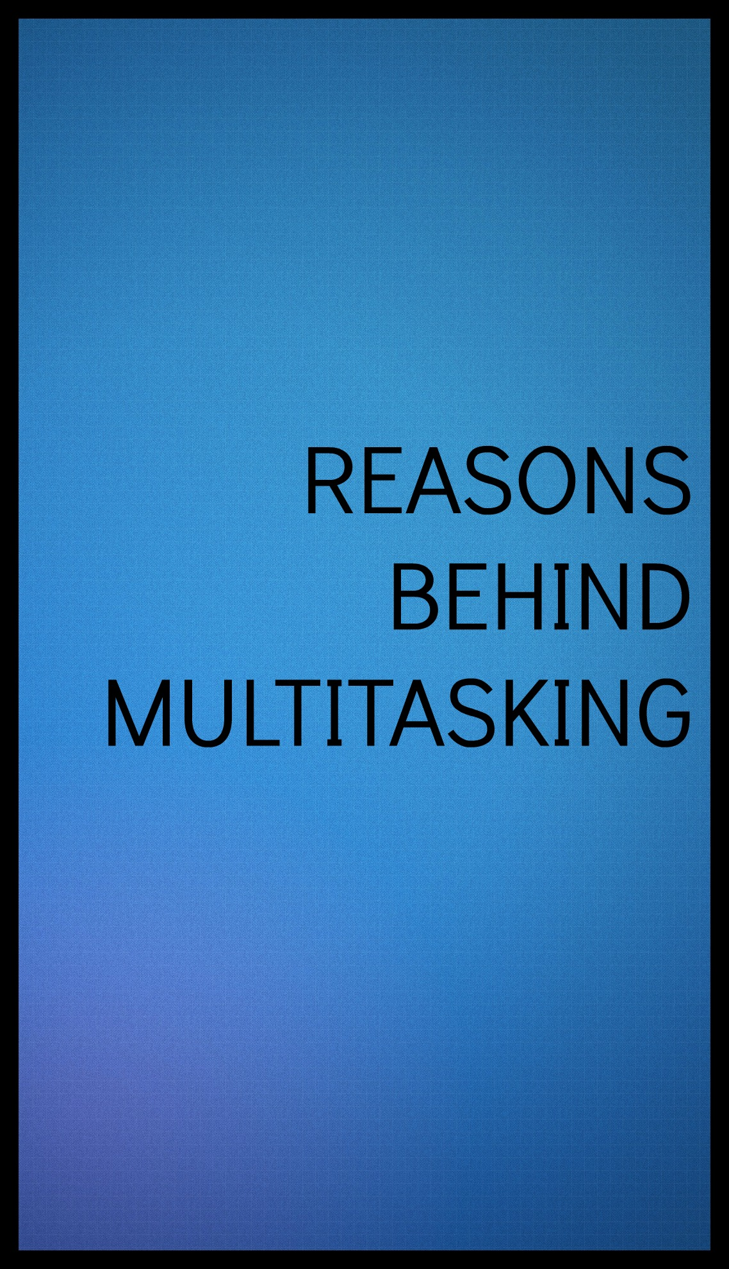

**We all do it: Texting while walking, sending emails during meetings, chatting on the phone while cooking dinner. In today’s society, doing just one thing at a time seems downright luxurious, even wasteful.**

**But chances are, you’re not doing yourself (or your boss, or your friends and family) any favors by multitasking your way through the day. Research shows that it’s not nearly as efficient as we like to believe, and can even be harmful to our health. Here are 12 reasons why you should stop everything you’re doing—well, all but one thing—and rethink the way you work, socialize, and live your life.**

**But the question is WHY do we multitask?**

**1) Employers think they need people who can multitask.**

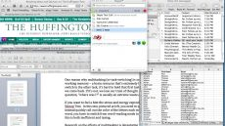

**Most computer screens have many applications open at the same time.**

**Many employers put "must be good at multitasking" in their job postings. Their thought may be that they need people who are ready to respond quickly to anything that comes up. This may be helpful in some cases. However, if what you want from your employees is** [**productivity**](https://www.psychologytoday.com/basics/productivity) **or** [**creativity**](https://www.psychologytoday.com/basics/creativity)**, you won't get it if you're constantly interrupting them or asking them to focus on two things at a time. In my last post I explained how multitasking allows only lower levels of brainpower to be focused on each task. What employers should be looking for instead of good multitaskers is**

**people who can create and manage work on multiple fronts during the day—not people who try to work simultaneously on more than one thing.  
2) It's so convenient - We mean, it's right there in your hands.**

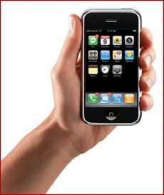

**Everything's right there in our hand.**

**You hardly have to move a finger to find out how your** [**team**](https://www.psychologytoday.com/basics/teamwork) **did, what tomorrow's weather will be, or what's on sale at your favorite store. And, it's only going to take a second, and then you can get right back to what you're doing . . . Um, not so much. It's been estimated that it takes more than 20 minutes to get back into the flow of what you're working on after an interruption at work.**

**3) We've become impatient.**

**Are you old enough to remember when we had to go all the way to the library to find out something we didn't know? And we had to locate books on shelves and then look in the index and turn pages to find what we were looking for? Now, we just need to enter a word or two in Google. And we're so used to instantaneous digital searching that we can no longer even fathom the idea of dial-up Internet access. These days, if we're listening to someone who's a slow talker, we check our email in the pauses. . . . Productivity and creativity require intense focus. But if we can't tolerate that quiet** [**concentration**](https://www.psychologytoday.com/basics/attention) **anymore, we've got something at our fingertips to fill any quiet moment.**

**4) We are convinced that the bad rap on multitasking is a hoax perpetrated by oldsters, who just don't get it.**

**Every older generation has foreseen the swift decline of civilization in whatever young people were doing. Can it be that kids, who have used computers all their lives, are different—that their brains function differently? In one sense younger people are better multitaskers. That's because working** [**memory**](https://www.psychologytoday.com/basics/memory)**, which is important for keeping the other task in mind when you're switching back and forth, peaks at the age of 25. So, with a larger working memory capacity, young people don't lose as much information every time they switch. But they still lose information and slow themselves down.**



**Young people aren't good at multitasking either**

**Have young people trained themselves to be better multitaskers? Can anyone? Probably not. Researchers at Stanford compared the performance of students who said they multitasked a lot to a group who said they hardly ever multitasked on three tests that involved multitasking. Surprisingly, the frequent multitaskers performed more poorly on all three tests. The researchers seemed shocked. Apparently, then, people do not multitask because they're good at it. They do it for some other reason.**

**5) People are bored.**

**A saying I've found all over the web goes:**

**"Multitasking is the art of distracting yourself from two things you'd rather not be doing by doing them simultaneously."**

**I think this is one reason why multitasking is so popular. We don't feel like doing that work, so we watch TV at the same time to make it seem less tedious. The problem is, it takes us longer to do the work, and we do it poorly. Plus, we don't really enjoy the TV show because we keep missing the best parts. . . .**

**So why not record the show, while you concentrate on your work. Then, if you watch the show and skip the commercials, you may actually come out ahead in time as well as in the quality of the work and your enjoyment of the entertainment experience.**

**Over the past decade, academic research has increasingly examined issues of multitasking and distraction as people try to squeeze more activities into their busy lives. Prior to the Internet age, some cognition science research focused on how behavior might be better understood, improved and made more efficient in business, hospital or other high-pressure settings. But as digital technology has become ubiquitous in many people’s daily routines — and as multitasking has become a “lifestyle” of sorts for many younger people — researchers have tried to assess how humans are coping in this highly connected environment and how “chronic multitasking” may diminish our capacity to function effectively.**

**Living rooms, dens, kitchens, even bedrooms: Investigators followed students into the spaces where homework gets done. Pens poised over their “study observation forms,” the observers watched intently as the students—in middle school, high school, and college, 263 in all—opened their books and turned on their computers.**

**These are some of the activities students are found to be doing while studying: reading a book, writing on paper, typing on the computer—and also using email, looking at Facebook, engaging in instant messaging, texting, talking on the phone, watching television, listening to music, surfing the Web. Sitting unobtrusively at the back of the room, the observers counted the number of windows open on the students’ screens**

**and noted whether the students were wearing headphones. Students these days cannot go for 15 minutes without engaging their devices. By the time the 15 minutes were up, they had spent only about 65 percent of the observation period actually doing their schoolwork.   
But evidence from psychology, cognitive science, and neuroscience suggests that when students multitask while doing schoolwork, their learning is far spottier and shallower than if the work had their full attention. They understand and remember less, and they have greater difficulty transferring their learning to new contexts.**

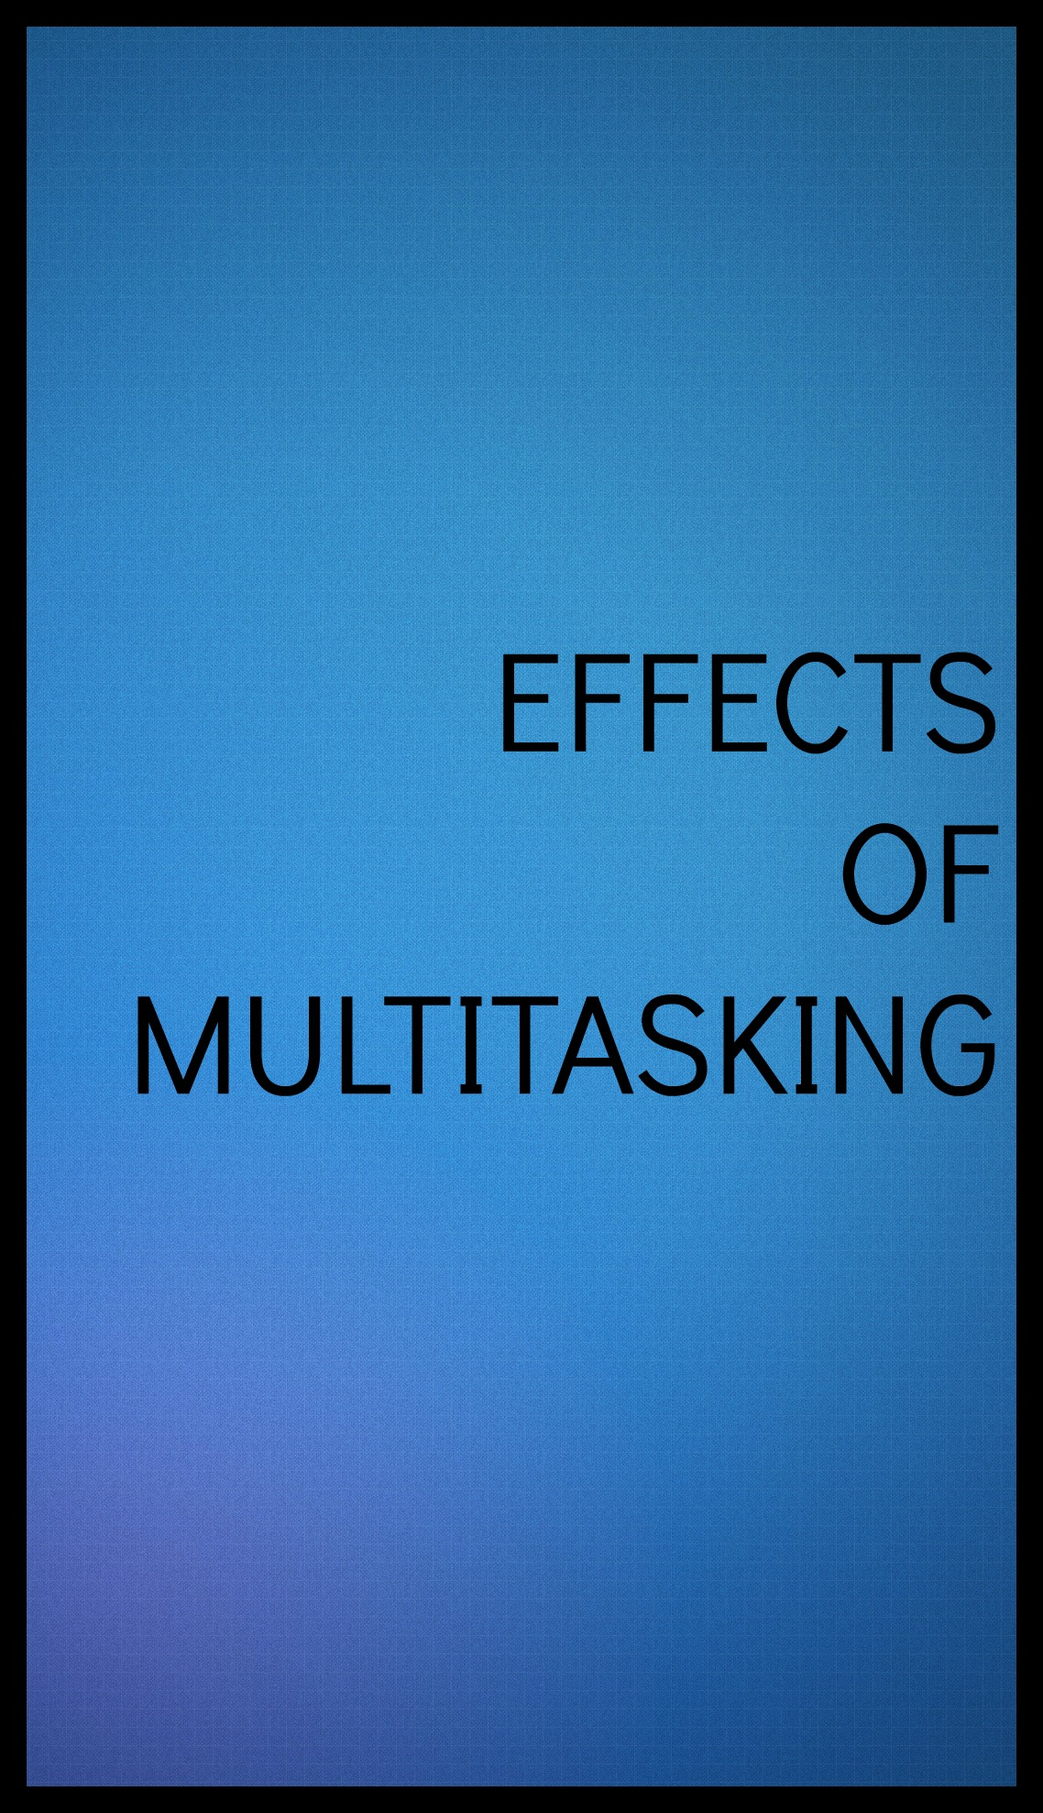

**Multitasking is a big part of modern life that everyone has an experience with. It refers to getting a great deal of work done in an efficient way. More recently, however, many time management experts have become rather critical of multitasking, stating that it makes you less productive.**

**Ill effects of Multitasking**

**Lack of Focus**

**When working on several tasks as once, such as talking on the phone, checking your email and writing a report, you can lose the focus required to adequately complete one item. Too many distractions break your concentration, which requires more time to come back to one task, find where you left off, and try to recreate your thought pattern.**

**Memory Impairment**

**Multitasking can lead to over-stimulation of your brain function. If you are working on a project or assignment and you are constantly interrupted by co-workers, phone calls, or customers, you risk forgetting details required to comprehensively finish the task.**

**Increased Stress Levels**

**Attempting to perform too many activities at one time can cause your stress levels to increase. Stress can lead to burnout, employee absences, and disability claims at work. Anxiety associated with multitasking at the office can reduce productivity and negatively impact a company's profits, especially a small business with few employees. When the office environment is too fast-paced for employees to perform their job functions**

**properly, it can hurt morale and cause higher turnover, which is costly to many companies. Turning off unnecessary electronics and allowing calls to roll to voice mail helps you feel that you have control over your environment and can finish the task at hand.**

**Cost**

**The bad effects of multitasking can take their toll on your life and livlihood. In addition, businesses and the economy suffer when employees are constantly interrupted with unnecessary distractions. It lowers your IQ and kills your performance thus affecting your efficiency.**

**However, research has demonstrated that our obsession with multiple forms of media does not necessarily have a negative impact.**

**Advantages of Multitasking**

* **Moving back and forth between different projects prevents**[**boredom**](http://www.mdhil.com/feeding-your-emotions-feeling-low-can-lead-to-binge-eating/)**, keeps you inspired and makes you more creative.**
* **Multitasking helps you learn how to deal with interruptions and**[**distractions**](http://www.mdhil.com/tips-to-concentrate-better-and-get-more-done/)
* **You develop the ability to cope even when there is chaos around you**
* **Even if the progress is minimal, you will manage to take more than one project or assignment to the next level, closer to your deadline.**
* **At home, you may want to talk to a friend or relative on the phone while ironing your clothes, since ironing requires little active cognitive ability on your part. However,**
* **It’s easy to multitask if you are doing simple chores like – cooking, watching TV and talking over the phone or checking**

**your email, talking over the phone and listening to**[**music**](http://www.mdhil.com/zumba/)**. In such case, switching your mental focus from one task to another is easy and does not require much effort.**

**Multitasking allows you to include different activities in your daily lives breaking the monotony.**



**Information and communication technologies (ICTs) have been widely usedfor pedagogical purposes and their significance in facilitating learning iswell recognised. As ICTs become a necessary component in classrooms, arrange of new media are readily available to students. Although universitiesare mainly considered educational environments, ICTs have penetratedthis environment as communication, entertainment and social tools as well.As such, students do not just limit their usage of new media to academicactivities. It raises the concern whether using ICTs has any side effects onteaching and learning, for example, whether using multiple new media at thesame time distracts students’ attention from the learning materials. A recentStanford study (Ophir, Nass & Wagner, 2009) showed that heavy multitaskersare worse at multitasking compared to light multitaskers in dividing their attention and handling multiple tasks. The finding suggests that multitaskingwith new media may have a negative impact on learning, even though themultitaksers themselves think that they are capable of learning effectively.**

**Scholars have found that multitasking with new media (e.g. mobile phonesand laptops) in classrooms is becoming common among college students fromGermany, Holland and the US (Vorderer&Hastall, 2009). The first questionthis survey tries to answer is about the popularity of multitasking with new media in JU classrooms. JU is a fully wired campus where students caneasily access the wireless Internet and mobile signals. We thus expect to see ahuge amount and a wide range of new media usage on campus.**

**The survey confirmed that mobile phones and laptops are**

**the two most utilised forms of new media in classrooms. The most utilisedfunction on mobile phones is the short messaging service (SMS) and the whatsapp. Studentsoften feel the urge to reply to such messages immediately, otherwise it maylook rude to the senders. They also use SMS to plan activities (e.g. lunch)around their lectures. Laptops are also widely used in classrooms for bothlearning and non-learning purposes. Students use laptops to take notes, check emails, finish their assignments, searchWikipedia for information, google unfamiliar terms the lecturer just mentioned, and so on.Laptops are also used to do things which may not be relevant to the lectures.Facebook and MSN are the two most mentioned social functions—both areused by students to keep in touch with their friends. YouTube videos, newssites, online shopping, and even games are**

**some of the other functions thatappear in students’ answers. When explaining the use of non-learningfunctions during lectures, students often cite the need to keep awake when lectures are boring as a reason. However, the survey found that listeningto MP3s is rare in classrooms because students tend to think that it makesattending the lecture meaningless if one cannot hear what the lecturer istalking about.**

**So after deciding on the relevance of the topic , we came to the conclusion as to what are the basic reasons to conduct this survey. These reasons are mentioned in the following points -**

* **Multitasking is becoming more and more prevalent in day to day life . It is an indispensable way of life and thus needs to be reflected on.**
* **Most student/ youth having too many work to be completed at the same the time are compelled to take up multitasking.**
* **Due to multitasking’s quintessential nature it is important to shed light on the way it impacts on people and their lives.**
* **No recent survey has been done to study the effects of multitasking on the youth in our country .**
* **No survey has been done in the recent past of Jadavpur University.**
* **This survey will enlist the details as to percentage of students/youth multitasking in the college and the impact of such action on their grades.**



**Rising rate of multitasking by the youth has raised alarm worldwide regarding their health and performance. Though not much surveys have been done in our country, there are some relevant survey from which we have gathered knowledge and built up our own survey. It is not possible to name all the articles that we have come across during this learning period so we will stick to some very important ones that helped us formulate the route of our survey. They are as follows –**

1. **“The relationship between multitasking and academic performance”- by Reynol Junco and Shelia R. Cotton. In this survey multitasking is used as a “phenomena of divided attention or task switching, concepts from the cognitive psychology literature that are more representative of howhumans attend to and process information” or more specifically it defined “multitasking as divided attention and non-sequentialtask switching for ill-defined tasks as they are performed in learning situations; for example, when a student is text messaging a friendwhile studying for an examination” The method of survey used by them are as follows**

**“ Participants**

**All students surveyed were U.S. residents admitted through the regular admissions process at a 4-year, public, primarily residential**

**institution in the Northeastern United States (N¼3866). The university’s Institutional Review Board for human subjects approved theresearch protocol. The students were sent a link to a survey hosted on SurveyMonkey.com, a survey-hosting website, through theiruniversity-sponsored email accounts. For the students who did not participate immediately, two additional reminders were sent, one weekapart. Participants were offered a chance to enter a drawing to win one of 90 $10Amazon.comgift cards as incentive. A total of 1839 surveyswere submitted for an overall response rate of 48%. The data were downloaded as an SPSS file directly from SurveyMonkey, screened for anomalies and analyzed using PASW (formally SPSS) Statistics 18.0. Initial screening**

**showed that 65 survey responses were unusablebecause they were not completed; therefore, thefinal sample size was 1774.**

**Instrument/measures**

**Key independent variables**

**ICT usage was measured through two main questions, each of which included various ICT types. To provide multiple measures for**

**accuracy checks in reporting, students were asked to estimate their average time spent searching for information online, on Facebook, email, IM, and talking on their cell phones as well as the amount of time they spent“yesterday”on each activity. These were evaluated by askingstudents:“On average, about how much time per day do you spend on the following activities?”and“How much time did you spend on eachof these activities yesterday?”with a prompt for each of the activities. Students used a pull-down menu to select the hours and minutes spentusing each ICT. Students were also asked“On average, how many text messages do you send in a day?”and“How many text messages did yousend yesterday?”Respondents were permitted to input a number of their choosing in a blankfield. Because multitasking while doingschoolwork outside of class was the variable of interest, overall time spent studying was included in the analyses to control for the possibility**

**that time spent multitasking was related to time spent studying (for example, it is possible that students who multitasked more increased**

**their amount of study time to compensate). Students were asked:“About how many hours do you spend in a typical 7-day week doing each of the following?”with a prompt for“preparing for class.”Hours and minutes for all variables were converted to minutes for this study.Frequency of multitasking was evaluated by asking students“How often do you do schoolwork at the same time that**

**you are doing thefollowing activities?”with prompts for searching for information online that is not part of schoolwork, Facebook,**

**email, IM, talking, and texting on their cell phones. The possible choices for multitasking frequencies were worded:“Very Frequently (close to 100% of the time);”“Somewhat Frequently (75%);”“Sometimes (50%);”“Rarely (25%);”and“Never.”For the analyses, these items were coded using afive-pointLikert scale with“Never”coded as 1 and“Very Frequently (close to 100% of the time)”coded as 5. To remove the proportion of the varianceattributable to time spent using ICTs in ways that did not involve multitasking with schoolwork, aggregate variables were created thatmultiplied the percentage estimate of frequency of multitasking using an ICT by overall time spent using that ICT. The aggregate variables**

**give an estimate of the time students spent multitasking while using each ICT. For instance, if a student reported doing schoolwork 50% of the time that they used Facebook and reported spending 100 min on the site overall, the value of the aggregate variable would be 50.**

**Internet skills were measured using a 27-item scale developed by Hargittai (2005). The original scale was created based on research that compared people’s actual online abilities with their responses to survey questions about knowledge of Internet activities (Hargittai, 2005;Hargittai& Hsieh, 2012). Students were asked “How familiar are you with the following computer and Internet-related items?”withprompts for 27 items focusing on Internet activities and technologies. Internet skills items were coded using afive-point Likert scale rangingfrom“Full”to“None.”For this study,“None”was coded as 1;“Little”was coded as 2;“Some”was coded as 3;“Good”was coded as 4; and“Full”was coded as 5. The Internet skills items have been used in a number of studies and have shown excellent internal consistency across data sets with Cronbach’s above 0.90 (Hargittai & Hsieh, 2012). Indeed, data from**

**the current study found the Internet skills items toexhibit excellent internal consistency with a Cronbach’sof 0.96.**

**In any linear model of ICT use and grades, it is important to control for high school GPA (HSGPA), consistently found to be the**

**Strongest predictor of overall college GPA (DeBerard, Spielmans, &Julka, 2004;Geiser &Santelices, 2007;Williford, 2009). In this study, HSGPA wasincluded in the analyses in order to parse out variance in the predictors attributable to pre-existing differences in academic ability and toalso place the other predictors in context. Academic ability might be a student background characteristic related to multitasking frequencyand to negative outcomes of multitasking (Junco &Cotten, 2011). For instance, it could be that students with lower academic ability may bemore susceptible to the negative academic effects of multitasking. Students gave researchers permission to obtain their actual high schoolgrade point averages (HSGPAs), which were submitted to the university during the admissions process. High school grades were measured**

**on a 4.0 scale ranging from 0 for ‘F’ to 4.0 for ‘A’.**

**Parental education was used as a proxy for socioeconomic status by asking students“What is the highest level of formal education**

**obtained by your parents?”with prompts for“Parent/Guardian 1”and“Parent/Guardian 2.”Parental education items were coded usingafive-point Likert scale ranging from“Advanced graduate”to“Less than high school degree.”For this study,“Less than high school degree”was coded as 1;“High school degree”was coded as 2;“Some college”was coded as 3;“College graduate (for example: B.A., B.S., B.S.E)”wascoded as 4; and“Advanced graduate (for example: master’s, professional, J.D., M.B.A, Ph.D., M.D., Ed.D.)”was coded as 5. The highest parentaleducation level was used for these analyses. Students were also asked to select their gender (male/female) and their ethnicity (African**

**American, Asian American, Hispanic/Latino, Native American, White/Caucasian, or Other).”**

1. **Another survey/seminar that influenced us was“ the impact of media multitasking on children’s learning and development” –by Stanford University scholar Claudia Wallis in 2010. The seminar sessions included the following points-**

* **Cognitive and social effects of media multitasking.**
* **Media multitasking in informal and formal learning environments.**
* **Designing educational tools that leverage media multitasking and multitaskers.**

**Five themes emerged from the seminar discussions:**

**1. There is a need for clearer definitions and a common vocabulary in this emerging, multidisciplinary field to facilitate both research and public discussion.**

**2. Panic and fear should not be permitted to obscure the upsides and creative potential unleashed by multitasking technology. Research must look at all sides.**

**3. Media multitasking is changing childhood and changing the workplace. Both present challenges that schools have yet to meet. Research can help fill the gap.**

**4. New tools and research methodologies must be developed. Current survey techniques don’t adequately capture fast-evolving behaviors and current dual-task studies do not adequately represent real-life multitasking.**

**5. A careful, long-term research agenda must be balanced with the demand for timely guidance for parents, educators, and businesses.**

**3. Another helpful article was by “ Media Multitasking among American youth : Prevalence , predictors, and pairing” by Ulla G.Foehr, Ph.D. December 2006. This article comes to the conclusion that “Two major**

**findings emerge from this research regarding the pairing of media. First, it is evident that when watching TV, a young person is not usually**

**media multitasking (indeed, isless likely to be multitasking than when using any other medium), but when a young person is media multitasking there is likely television involved. Second ,computer activity are the most multitasked activities in this study and, unlike the situation with television, music or reading, most of computer time devoted to secondary activities is overwhelmingly media-based. When teens engage in a computer activity such as IM or web surfing, they spend the majority of the time also using other media, especially on other activities on the computer. The way young people use the computer appears to be very different from how they use more traditionalmedia .When they watch TV, listen to music or read, non-media activities such as eating and doing chores dominate when they are engaging in secondary activities. However, when they are on the computer, they usually are doing something else, and media activities dominate as secondary activities. In fact, for teens using the computer, the most consistent secondary activity is another computer activity. The computer trulyappears to be a media multitasking station, and may be at least partly responsible for an increase in media multitasking. ”**



**Media multitasking is a young area of inquiry. It lacks a common language and agreed-upon definitions of the most basic terms—including multitasking itself. And yet the phenomenon has become ubiquitous so fast that there is an anxious, urgent demand for guidance and understanding coming from many quarters: parents, educators, employers, workers, marketers.The growth and expansion of communication technology have created a multitasking generation of students who believe they are utilizing time more effectively by performing two or more tasks simultaneously. Multitasking refers to the concurrent processing of two or more tasks through a process of context switching. However, research by neuroscientists show that multitasking reduces the brain’s ability to effectively retrieve information. The purpose of this study is to empirically examine whether multitasking in class affects the grade performance of students.**

**Many people take pride in how well they multitask. But new research suggests some big downsides to it.Multitasking increases the chances of making mistakes and missing important information and cues. Multitaskers are also less likely to retain information in working memory, which can hinder problem solving and creativity.Instead of trying to do several things at once—and often none of them well specialists suggest what they call set shifting. This means consciously and completely shifting your attention from one task to the next, and focusing on the task at hand. Giving your full attention to what you are doing will help you do it better, with more creativity and fewer mistakes or missed connections**.

**So, through this survey we aim to study the following –**

* **We aim at finding whether multitasking (while studying) amongst students affects their grades. We have taken into consideration instances, such as whether a student uses mobile phone while studying.**
* **We also aim at finding whether continued multitasking amongst students affects their health with age.**

**Figure 1: Depicting use of cell phones while studying**

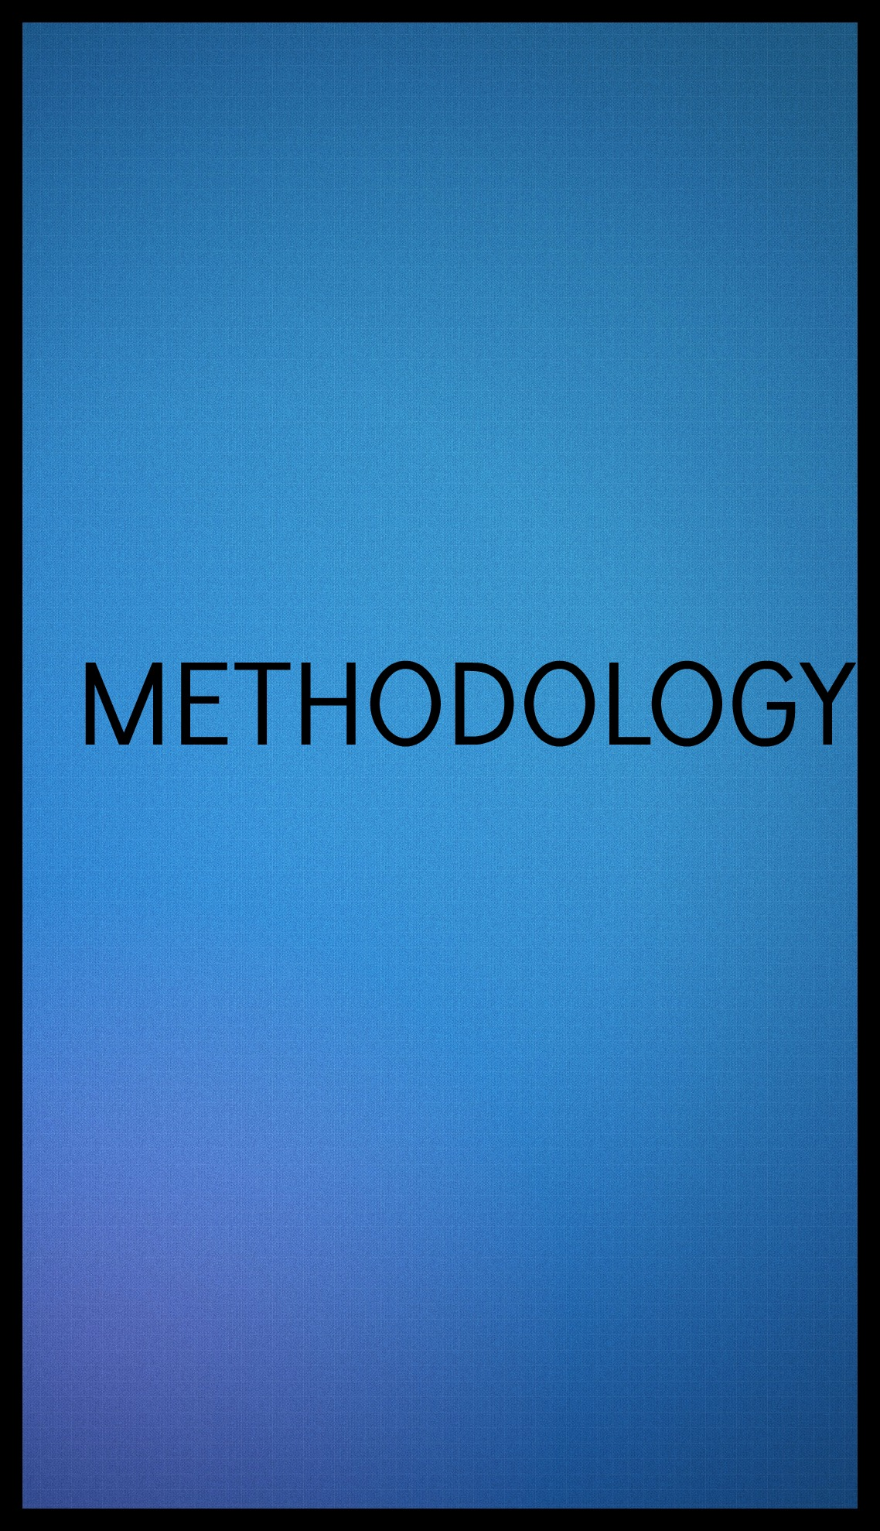

**Here we attempt to explain how we intend to examine the effect of multitasking while studying and other factors on the grades of the student.**

**This section is divided into three parts. The first part deals with the preparation of our questionnaire .the second part explains how we used the questionnaire to collect data from subjects of our study .the third part deals with the method by which we analyze the results obtained from the survey .**

1. **THE DESIGN OF THE QUESTIONNARE**

**While designing the questionnaire (provided in the later pages), we tried to keep in mind what we wanted to know from the subjects of our study and how best we could get the required information from them. The objective of the questionnaire pretty much constitutes the scope of our study and has been summed up there. We now discuss how we actually elicited the information required to meet the said objectives.**

**While designing the actual questionnaire we felt it important to pay due attention to the psyche of the people we would interview. We wanted to make sure that while eliciting as much information as possible ,we should not make the questionnaire too lengthy such that respondents lose interest and give random ,untruthful answers simply for the sake of finishing the questionnaire quickly, or worse still, not answer all the questions. Thus, the length of each question as well as the total number of questions had to be kept in check.**

**We have to decided to concentrate only on students of the age group 18-24. It must be mentioned that we first conducted a pilot survey of 50 students chosen at random ,which gave us better insights into the psyche of students and helped us to add more relevant questions in questionnaire for the final survey . To make answering easy for the respondents we put questions whose answers could be made by ticking alone. We attempted to avoid open ended questions and vague/ ambiguous questions as far as possible.**

**Now we discuss the actual questions we put forward to our respondents:**

**QUESTIONNAIRE**

1. Gender

Female Male

2a) Age :

b) Profession :  
 c) Approximate monthly family income( In Rupees) :   
  
 Less than 5000 5000-15000

15000-50000 Above 50000

3. Do you Multi-task?

Yes, Always Yes, Sometimes

No, Rarely No, Never

4. When do you Multi-task?

1. Studying and texting
2. Yes, Always Yes, Sometimes

No, Rarely No, Never

b. Studying and Watching TV

1. Yes, Always Yes, Sometimes

No, Rarely No, Never  
c. Studying and listening to music

1. Yes, Always Yes, Sometimes

No, Rarely No, Never

d. Eating and watching TV

1. Yes, Always Yes, Sometimes

No, Rarely No, Never

5. Do you work faster when you multi-task?

Yes, Always Yes, Sometimes

No, Rarely No, Never

6. Is the work quality better when you multi-task?

Yes, Always Yes, Sometimes

No, Rarely No, Never

7. Why do you multi-task?

I am very Busy Reduces work pressure

Allows me to finish Due to situational need  
 greater number of   
 jobs

8. Do you like multi-tasking?

Yes, Always Yes, Sometimes

No, Rarely No, Never

9.Does multi-tasking help?

Yes, Always Yes, Sometimes

No Rarely No, Never

|  |  |  |
| --- | --- | --- |
| *Main Daily Activities* | **Major lifestyles, Energy expenditure (In Minutes per day)** | **Specify the time you would like to allocate to each of the activities** |
| Sleeping/Resting/Relaxing |  |  |
| Sitting, eating, chatting |  |  |
| Standing/Light-activity work/cooking |  |  |
| Walking slowly, driving, bathing, childcare |  |  |
| Light manual work, sweeping,  cleaning utensils, washing clothes |  |  |
| High intense manual work & sports activities |  |  |
| Studying |  |  |

10. Please Specify How many hours you Multitask in a Day for the above mentioned activities

Section II

11a) How many hours do you spend studying each day?

B Less than two hours 2 hours

3 hours 4 hours  
 5 hours Above 5 hours

b) According to you how do you allocate your studying time mentioned above?  
 Study Multitasking  
 100% 0%  
 85% 15%  
 75% 25%  
 50% 50%  
 25% 75%

12. Attendance in class/workplace?

90-100% 75-90%

65-75% Below 60%

13. Do you check your mobile phone during classes?

Yes, Always Yes, Sometimes

No, Rarely No, Never

14a) Percentage of marks secured in the last examination

___________

b) Percentage scored in Higher Secondary Examination  
 Below 50% 50-60%

60-80% Above 80

15. Are you attentive in class while multi-tasking?

Yes, Always Yes, Sometimes

No, Rarely No, Never

16. Do you have to take notes from others even when you are present in class?

Yes, Always Yes, Sometimes

No, Rarely No, Never

17 Do you think multi-tasking harm your grades?

Yes, Always Yes, Sometimes

No, Rarely No, Never

Section III

18. Mode of transport to college/workplace?

Walking Auto

Bus Car

Train Others

19. How much time does it take for you to come to college/work place?

0-30 minutes 30-60 minutes

1-1.5 hr 1.5-2.0 hr

20. If it take more than 1 hour, which of the following do you prefer to do?

Sitting idle listening to music

Reading /studying playing games in your phone/tablet/laptop

21. Distance from place of stay to college/workplace?

0-5 km 5-10 km

10-15 km 15-20km

20 km and above

Section IV

22. Do you feel tired after multi-tasking?

Yes, Always Yes, Sometimes

No, Rarely No, Never

23. Does multi-tasking cause serious stress issues?

Yes, Always Yes, Sometimes

No, Rarely No, Never

24. Does multi-tasking slow down your thought process?

Yes, Always Yes, Sometimes

No, Rarely No, Never

25. Does multi-tasking affect your health?

a)

a. Yes No

b) If yes, then how?

High blood pressure Fatigue

Uncontrolled Diabetes Spondylitis

Eye problem Sinus

Migraine Others (specify) _________________________

26. Do you think multi-tasking should be allowed for students?

a. Yes No

1. **THE METHOD OF DATA COLLECTION**

**We now aim to explain how the data was collected by us for the survey. Like we had previously mentioned our survey dealt with student population between the age 18 – 24. So focusing this student population we drew a sample of size 500. But due to incomplete filling, ambiguous answers, false answers,or inconsistent preferences we had to drop about 150 data. So at the end of the sample survey we had a total of 350 data.**

**Armed with this data we started off with the basic experiments to find the relations-**

1. **Between multitasking and grades**
2. **Between multitasking and health**
3. **TYPES OF DATA**

**The data that we mostly collected was measured on Likert scale excepting two variables. These two variables were the two dependent variables of their respective regressions. These variables are of continuous nature.**

**On the Likert scale we have started from 1 to 4 in most of the cases. Marking 1 to the least important factor affecting our regression and awarding 4 points to the most important factor .**

**In some cases when more than four options were presented the marking scheme was changed accordingly and values higher than 4 were also allotted .**

1. **METHOD OF ANALYSIS**

**For both of our regression models, we have attempted to show values andsigns of all the regression coefficients that we have considered, their standard errors, the values of t-statistic, the probabilities associated with these values and the 95%confidence interval, RMSE (root mean squared error), R­­2  and F statistics.**

**We have used multivariate regression analysis models in this survey. Multiple linear regression is a generalization of linear regression by considering more than one independent variable, and a specific case of general linear models formed by restricting the number of dependent variables to one . The basic model for multivariate linear regression is**

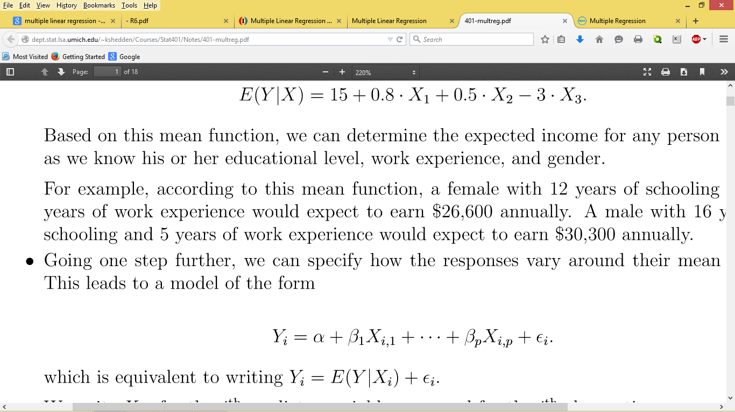

**Whereαis called theinterceptand theβjare calledslopesorcoefficients.**

**We write Xij for the jth predictor variable measured for the ith observation.**

**The values βj represent parameter to estimated, we have used the method of Ordinary Least Squares(OLS) to estimate the unknown parameters in such linear models. the Least Squares method is used to fit a straight line through a set of data-points, so that the sum of the squared vertical distances (called residuals) from the actual data-points is minimized.**

**As mentioned earlier we have calculated certain components. Each of these components has certain significance. The sign of the coefficient is important as it tells us about the nature of the relationship between the independent and the dependent variables. In other words, it examines whether the value of coefficient increases (if the sign is positive) or decreases (if the sign is negative). The value of the independent variable rises. The magnitude of this change is determined from the values obtained from the two multivariate regression analysis that we carried have out.**

**The standard error is the estimate of the standard deviation of the relevant regression coefficient. If the value of the coefficient is significantly different from the standard error then we can say that the coefficient can never attain the value zero, which is the null hypothesis of our tests, that is, there will be some effect of any change in the value of independent variable on that of dependent variable.**

**The value of t-statistic is obtained by deflating the value of the regression coefficient by the standard error. It actually tells us how far the relevant variables are able to influence the value of the dependent variable.**

**RMSE (Root Mean Squared Error) is a quadratic scoring rule that measures the average magnitude of error. It is calculated by taking each observed value and subtracting it from the actual values, then adding the values thus obtained, deflating them by number of observations and finally taking the square root of the values we thus obtain.**

$R^{2 }$**is the square of the multiple correlation coefficient. It measures the proportion of variation in the dependent variable, explained by linear combinations of repressors. The formula to calculate the same is: $R^{2 }$ equalsExplained sum of squares (ESS) divided by the residual sum of squares (RSS).**



**After describing how we carried out our survey , we now discuss the observations made during the sample survey .**

**The very first thing we see here is the gender of our respondents, we first see the gender distribution in our survey.**

**Figure2 : Depicting the gender share of all the respondents**

**Next we examine the ages of the students interviewed by us. We find the age group to be between 18-24.**

**Figure 3: Depicting the various age group and the percentage of respondents in each such groups.**

**Next we look into the various results that we got when we asked the students questions relating to their multitasking**

**Question .**

**Do you Multi-task?**

**Yes, Always Yes, Sometimes**

**No, Rarely No, Never**

**On the basis of the results received by us we compiled a pie chart**

**Figure 4: Depicting multitasking done according to respondents**

**Question**

**When do you Multi-task?**

**(Studying and using cell phone)**

**Figure 5: Depicting use of cell phones by students while studying.**

**Question**

**When do you Multi-task?**

**(studying and watching TV)**

**Figure 6: Depicting watching of television while studying by students.**

**Question**

**When do you Multi-task?**

**(studying and listening to music)**

**Figure 7: depicting listening to music while studying by students.**

**Question**

**When do you Multi-task?**

**(Eating and watching television)**

**Figure 8: Depicting eating and watching television (together).**

**Question**

**An opinion based question:**

**Does multitasking affect the health of the respondent?**

**Figure 9: Depicting whether according to the correspondent multitasking affects their health.**

**Question**

**An opinion based question:**

**According to respondents should multitasking be allowed for the youth?**

**Figure 10: Depicting respondents opinion whether multitasking should be allowed for students.**

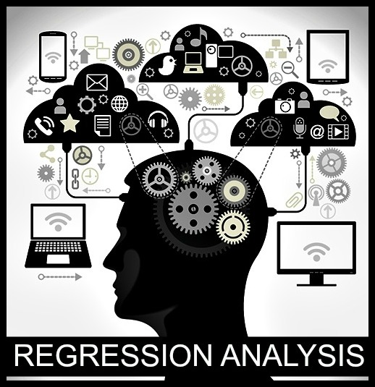

**After observing the sample traits we now use the method of regression to find their mathematical and statistical base. So, now from 350 samples obtained from our survey,we have constructed two multivariate regression models. The first one dealing with the effect of multitasking while studying on grades. The second one being the effect of prolonged multitasking with increase in age on health.**

**Now we divulge into the details of the two regression equations that we have constructed.**

**REGRESSION 1**

**Does multitasking while studying affect grades ?**

**Independent variables**

1. **Time spent studying.**
2. **Attention paid in class.**
3. **Multitasking while studying.**
4. **Taking notes from others even when physically present in class**.

|  |  |
| --- | --- |
| **Independent Variable Description** | **Variable Name** |
| 1. **Time spent studying** | **Time** |
| 1. **Attention paid in class** | **attention** |
| 1. **Multitasking while studying** | **multitasking** |
| 1. **Taking notes from others even when physically present in class** | **Notes** |

**Dependent variable – marks**

|  |  |
| --- | --- |
| **Dependent variable description** | **Variable name** |
| **Marks obtained in the last exams** | **mark** |

**So the simple linear regression equation is**

**mark = a + b1 time +b2 attention + b3 concentration + b4 notes**

**a= constant.**

**b1 = measures the effect of time spent on studying on marks.**

**b2 = measures the effect of attention paid in class on marks.**

**b3 = measures the effect of multitasking while studying on marks.**

**b4 = measures the effect of taking notes from others even when physically present in class on marks.**

**Variable types**

|  |  |
| --- | --- |
| **Variable Name** | **Variable Type** |
| **mark** | **Continuous variable** |
| **Time** | **Categorical variable** |
| **attention** | **Categorical variable** |
| **multitasking** | **Categorical variable** |

**NULL HYPOTHESIS REGARDING THE COEFFICIENTS**

1. H0 : b1 = 0
2. H0 : b2 = 0
3. H0 : b3 = 0
4. H0 : b4 = 0

**We decide the threshold level to be**

* **p< 0.01 : very strong presumption against null hypothesis.**
* **0.01 < p <0.05 : strong presumption against null hypothesis.**
* **0.05 <p < 0.1 ; low presumption against null hypothesis.**
* **p> 0.1 : no presumption against null hypothesis .**

**Using the data obtained from our sample survey and the above regression equation, we now perform the multiple regression analysis using STATA to obtain the following results**

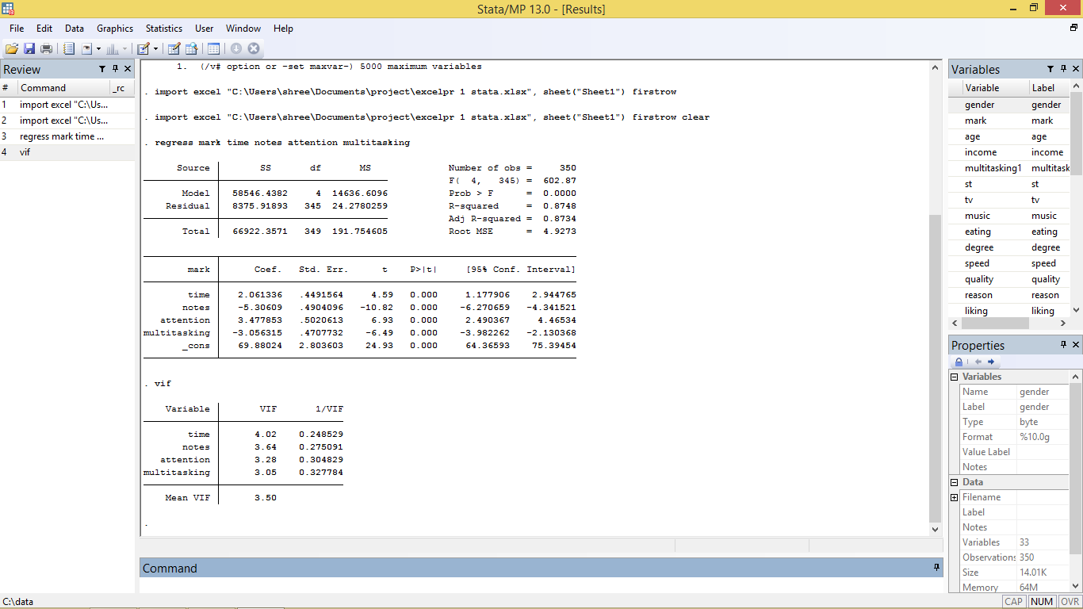

**OBSERVATIONS**

1. **The sign of the coefficient for time spent on studying on marks is a positive value denoting that there is a positive correlation between the two .In other words more the time spent on studying more is the marks rewarded to the student. The p value being less than 0.01 allows us to reject the null hypothesis (which states that the coefficient will be zero) at 95% level of confidence.**
2. **The sign of the coefficient for attention paid in class is positive, proving that greater the attention paid in class greater is the marks scored in the examination. The p value being less than 0.01 allows us to reject the null hypothesis (which states that the coefficient will be zero) at 95% level of confidence.**
3. **The sign of the coefficient for multitasking while studying is negative proving that more a student multitasks while studying more is his/her chances of getting lower marks . The p value being less than 0.01 allow us to reject the null hypothesis (which states that the coefficient will be zero) at 95% level of confidence.**
4. **The sign of the coefficient for taking notes from others even when physically present in class is negative proving that more a student has**

**to take notes from others more is his/her chances of scoring less marks in the examinations. The p value of the coefficient is less than 0.01 which allows us to reject the null hypothesis (which states that the coefficient will be equal to zero) at 95% confidence level .**

**REGRESSION 2**

**Does prolonged multitasking with increase in age have an effect on health?**

**Independent variables**

1. **Age**
2. **Multitasking**
3. **Degree of multitasking**

|  |  |
| --- | --- |
| **Independent Variable Description** | **Variable Name** |
| 1. **Age** | **age** |
| 1. **Multitasking** | **Multitasking1** |
| 1. **Degree of multitasking** | **Degree** |

**Dependent variable - health**

|  |  |
| --- | --- |
| **Dependent Variable Description** | **Variable Name** |
| **Health hazards/impacts** | **health** |

**So simple linear regression model is**

**health = a + b2 age + b3 multitasking1 + b4 degree**

**a= constant**

**b2 = measures the effect of age on health**

**b3 =measures the effect of multitasking on health**

**b4 = measures the effect of degree of multitasking on health**

**Variable types**

|  |  |
| --- | --- |
| **Variable Name** | **Variable Type** |
| **health** | **Continuous variable** |
| **age** | **Categorical variable** |
| **Multitasking1** | **Categorical variable** |
| **Degree** | **Categorical variable** |

**NULL HYPOTHESIS REGARDING THE COEFFICIENTS**

* H0 : b2 = 0
* H0 : b3  = 0
* H0 :b4 = 0

**The thresholds that we consider**

* **P < 0.01 : very strong presumption against null hypothesis**
* **0.01 < P < 0.05 : strong presumption against null hypothesis**
* **0.05 < p < 0.1 ; low presumption against null hypothesis**
* **P > 0.1 : no presumption against null hypothesis**

**Using the data obtained from our sample survey and the above regression equation, we now perform the multiple regression analysis using STATA to obtain the following results**

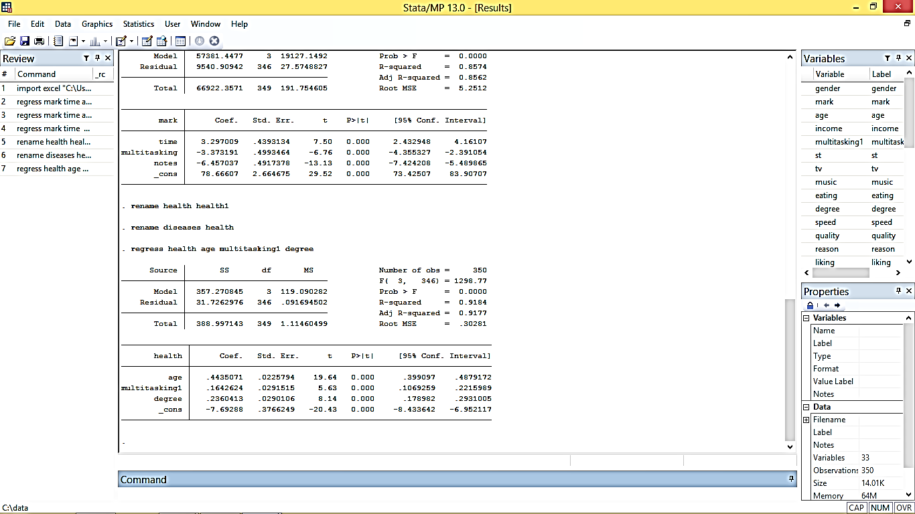

**INFERENCE**

* **The sign of the coefficient for age being positive shows that health is positively affected by age. The p value being less than 0.01 gives a strong presumption against the null hypothesis at 95% level of confidence.**
* **The sign of the coefficient for multitasking being positive shows that health is positively affected by multitasking .The p value being less than 0.01 thus allows us to reject the null hypothesis (that the coefficient for multitasking is zero) at 95% confidence interval.**
* **The sign of the coefficient for degree of multitasking being positive shows that health is positively affected by the degree of multitasking. The p value being less than 0.01 allows us to reject the null hypothesis (that the coefficient for degree of multitasking is zero) at 95% confidence interval.**



**REGRESSION 1**

**Values for variables namely**

* **Time**
* **Attention**
* **Multitasking**
* **Notes**

**have been directly obtained from the questionnaire . These variables are being measured using the Likert scale where 1 point is awarded to the the lowest rank and 4 points to the highest.**

**REGRESSION 2**

**Values for the variables namely**

* **Age**
* **Multitasking1**

**have been directly obtained from the questionnaire .**

**the variable “degree” measuring the degree of multitasking done by the respondent on an average is measured by a simple average of points awarded to the following questions (measured in Likert scale)**

* **Studying and texting**
* **Studying and watching television.**
* **Studying and listening to music**
* **Eating and watching television.**

**The nearest integer value of the simple average is taken as the degree of multitasking.**

**As for the variable “health” which measures the amount/ impact of multitasking on health, it has been calculated on the basis of number of diseases / health related problems faced by the respondent and whether multitasking affects his or her health . One point has been awarded to each problem mentioned by the respondent, faced due the pressure of multitasking. A simple average of this variable along with the preference of the respondent on whether multitasking affects his or her health is taken as the value of the variable.**



**When there is a perfect linear relationship among the predictors, the estimates for a regression model cannot be uniquely computed. The term collinearity implies that two variables are near perfect linear combinations of one another. When more than two variables are involved it is often called multicollinearity, although the two terms are often used interchangeably.**

**The primary concern is that as the degree of multicollinearity increases, the regression model estimates of the coefficients become unstable and the standard errors for the coefficients can get wildly inflated. In this section, we will explore some Stata commands that help to detect multicollinearity.**

**We can use the vif command after the regression to check for multicollinearity. vif stands for *variance inflation factor*. As a rule of thumb, a variable whose VIF values are greater than 10 may merit further investigation. Tolerance, defined as 1/VIF, is used by many researchers to check on the degree of collinearity. A tolerance value lower than 0.1 is comparable to a VIF of 10. It means that the variable could be considered as a linear combination of other independent variables. Since our independent variables are mostly categorical we do not require a multicollinearity check.**



**From the results derived from our regressions, we can curtain that multitasking in class does affect a student’s performance. Although students consider multitasking a great way to work, but in reality, texting in class and listening to a lecture simultaneously or texting and writing an examination degrades the quality of their conduct. Because the brain cannot fully focus when multitasking, students take longer to complete tasks and predisposed to errors.**

**We can see that a student’s result is also affected by his ability to take notes in class which in turn deteriorates if he multitasks while taking notes, his attention in class while multitasking as well as time spent by the student on studying (on average) per day. Those who allot more time to only studying and less time to texting while studying, perform better in examinations than the ones who do not.**

**Moreover, from the result of our second regression we can conclude that multitasking affects health of the youth. Multitasking increases the stress levels of students and causes depression. The stress of prolonged multitasking may become even more dangerous. It leads to chronic diseases like migraine, sinus, back pain as well as eye problems, uncontrolled diabetes, high blood pressure, etc.**

**Our results also show that the health of the respondent is affected by his or her age. With increased age, the ability to multitask becomes less. So multitasking deteriorates the health of the older people more than the younger ones.**

**Our results hence show that the future generation’s health is at risk and it may lead to dire consequences. We should look forward to remedial measures to come out of this vicious circle of multitasking.**



**The growth and expansion of communication technology have created a multitasking generation of students who believe they are utilizing time more effectively by performing two or more tasks simultaneously. Multitasking refers to the simultaneously doing of two or more tasks through a process of switching from one task to another in a very short interval. The brain cannot process two relatively different thoughts at the same time. Whenever the brain switches from one task to another, it saves the current state of the former task so it can come back to it later.Therefore, switching between tasks costs more time because information is being processed at a much slower rate. It reduces accuracy of work,and reduces the brain’s ability to retrieve information. For example, students who study while listening to music or using the cell phone may find it difficult to retrieve that information during exam time.**

***STUDYING***

***RESULTS IN :***

***DECREASED PRODUCTIVITY, REDUCED ACCURACY***

R

[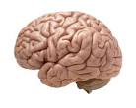](http://www.google.co.in/url?url=http://www.wired.com/2014/07/everything-you-need-to-know-about-the-10-brain-myth-explained-in-60-seconds/&rct=j&frm=1&q=&esrc=s&sa=U&ei=mPYGVYGVB8KOuATm6YLoDg&ved=0CDMQ9QEwDw&sig2=81a2_4TFEftYLRf-q1B-nA&usg=AFQjCNGoLmG57yo8wReYUNxKexM3SSn14w)

***TEXTING***

***LISTENING MUSIC***

**Following can be listed as ways of reducing negative effects of media multitasking:**

* **Turn off instant notification alerts as it can distract you from present work.**
* **The best way is to turn off as many gadgets as possible so as to allow us to focus on task at hand.**
* **Schedule intervals throughout the day to check e-mails, messages, news,blog or weather.Keeping them open all day is another way of distraction.**
* **People suffering from serious stress issues due to multitasking should make out time to relax or meditate.Exerciseatleast once a day. Make**

**sure that you stay away from your phones and laptops during your exercise.**

* **Develop a habit of not multitasking wherever you can.**

**Multitasking can seem like an advantage, but constantly performing several tasks at once can lead to a drop in productivity,concentration and efficiency. Be aware of the negative side effects of trying to accomplish too much at once, and complete one task at a time to regain control over your responsibilities.**



* **Incomplete filling of questionnaire – Most respondents do not fill up the questionnaire fully due to lack of time and enthusiasm. This created a lot of problem for us as all these samples had to be rejected thus a lot of potential data was lost.**
* **Lack of incentive- Most respondents lacked incentive to undergo the survey and divulge personal facts. As a result a large group of people whose opinion was needed had to be forgone.**
* **Obtaining true data on the variables like marks, income and othsome respondents where not keen on revealing their actual marks and income. This caused a problem of obtaining true values for such variables.**
* **Segregating data. – one of the major problems faced by us was that of segregating data. By segregating data we mean differentiating between true data and false data and selecting only the true data while rejecting the false one.**
* **Removing ambiguous data – many respondents had plied us with ambiguous data values that were realized later while scrutinizing the filled questionnaire. These samples had to be removed as they would foil our attempts to obtain correct results.**
* **Shortage of time – we were faced with dire consequences of shortage of time while undertaking this project. As a result we were unable to elaborate our project as initially planned.**

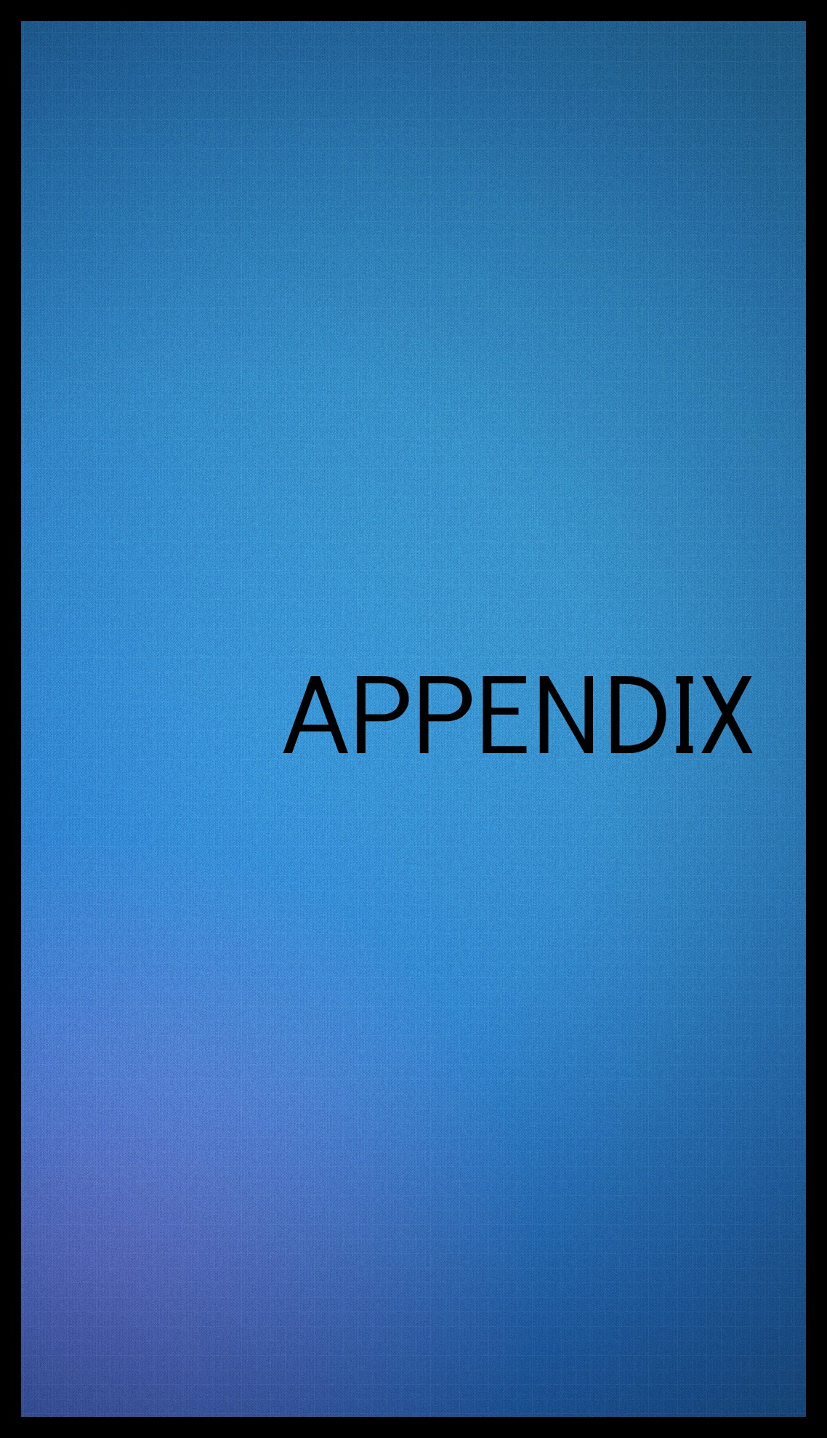

1. **Other regressions**

**The first regression had two variables namely notes and attention which were closely related. Thus many of us were afraid that they may be affecting the value of R2  so we decided to run the regression without these two variables together. Here is a glimpse of the regressions**

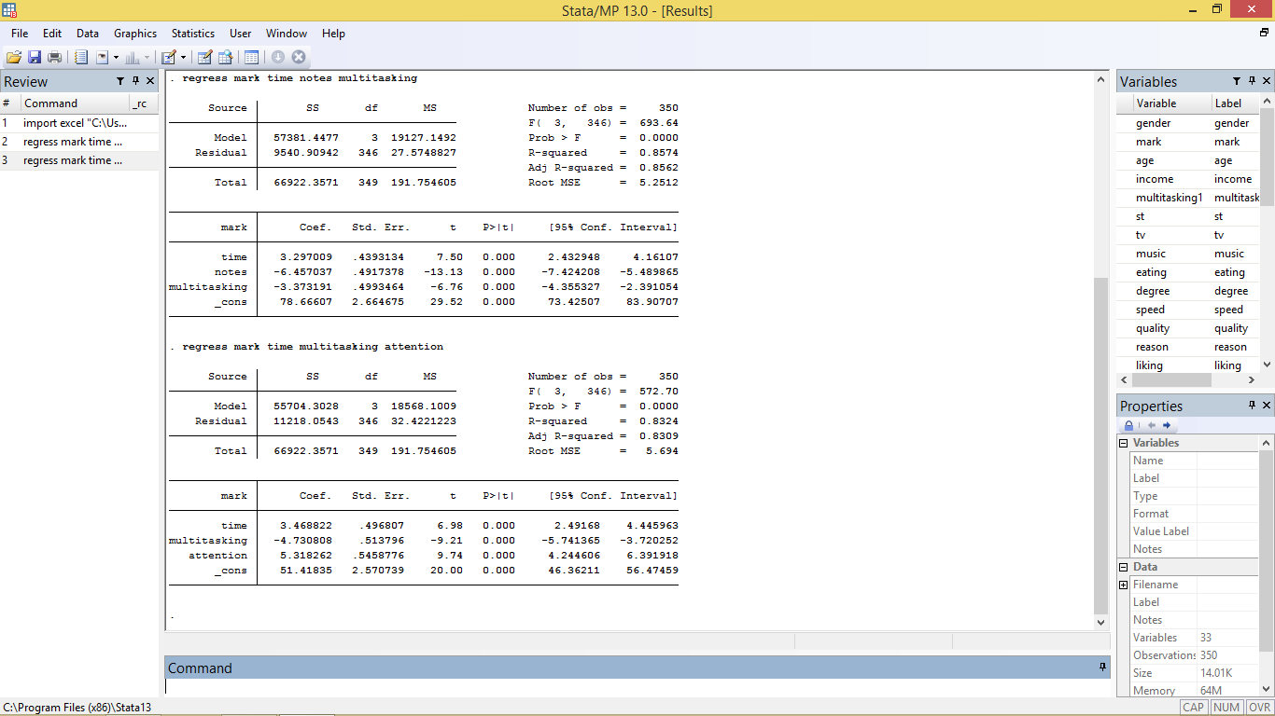

**In the first case we dropped the variable “attention”and the R square is approximately 0.86, in the second case we get R square to be 0.83(approximately). Both of which is less than 0.87 – the R square that we got from the regression. Thus we concluded that both the variables when used by us resulted in explaining the regression better.**

**II. AN EXPERIMENT**

**We conducted an experiment to gain further insight into the effects of multitasking on both accuracy and swiftness of the respondent. Due to shortage of time and man power we could not receive very precise results. But we obtained the following results.**

**We conducted the experiment with 50 individuals of age group 18-24. The duration of the experiment was 10 minutes. All the participants were provided with a set of ten questions based on basic mathematics and aptitude. Half of the individuals were asked to use the popular instant messaging system “whatsapp” to send a previously announced text message to the invigilators of the experiment. These individuals whom we referred to as multitaskers were asked to send the message thrice. The message that we had asked the multitaskers to send was “THE QUICK BROWN FOX JUMPED OVER THE LAZY DOG.” The speciality of the message was that it involved all the letters of the alphabet series. The non-multitaskers on the other hand were not allowed to do anything other than solving the question set. Talking or any kind of communication or other disturbances were strictly prohibited during those 10 minutes.**

**The result that was obtained was that –**

1. **Multitaskers attempted fewer questions than the non-multitaskers.**
2. **Multitaskers got fewer questions correct than the non-multitaskers.**
3. **Non –multitaskers on an average performed better than the one multitasking.**
4. **None of the multitaskers could send all the three messages to the invigilators.**

**The inference that we drew from this small experiment was –**

1. **Multitasking reduced accuracy of the individuals.**
2. **Multitasking prevented the individuals from completing any of the work properly.**



**On completion of the project we find that our work was still away from perfect. On looking back we realized the drawbacks of our survey. Our survey is based on a linear model. However it may be the case that the variables in reality may not be linearly related. Not much of the population has been surveyed given that our population is the whole of the youth of the age group 18-24. The experiment we conducted lacked mathematical base. Due lack of time a proper mathematical base could not be formed to decipher actual results. Not much research has been done on this topic in Indian context so it was difficult to find out the variables that affect Indians only or matter importantly in such circumstances. However, full effort on our part was given to reduce any known errors. In case any such errors are found we are extremely sorry for its presence.**



**Multitasking is an important criteria in today’s world. Shortage of time coupled with immense work pressure compels us to multitask even if we do not want to undertake it. Our project aims at finding out the effect of multitasking on grades and health. After using mathematical tools like regression we come to the various results-**

1. **Grades/marks is affected by multitasking. Higher multitasking while studying leads to lower marks received in examinations. Marks is also affected by variables like time spent studying, notes collected from people even when physically present in class, and attention paid in classes.**
2. **Health is negatively affected by prolonged multitasking with age. It is also affected by the age of the respondent and the degree of multitasking embarked on to.**

**Thus we come to the basic conclusion that multitasking harms the respondent both in terms of academic performance as well as health specifications. But we also reached the conclusion that the increasing burden of jobs and the desire to attain perfection is forcing many of us to take to the unpleasant job of multitasking. As a request to the readers we would be grateful if they take to prioritizing their work or managing time efficiently.**

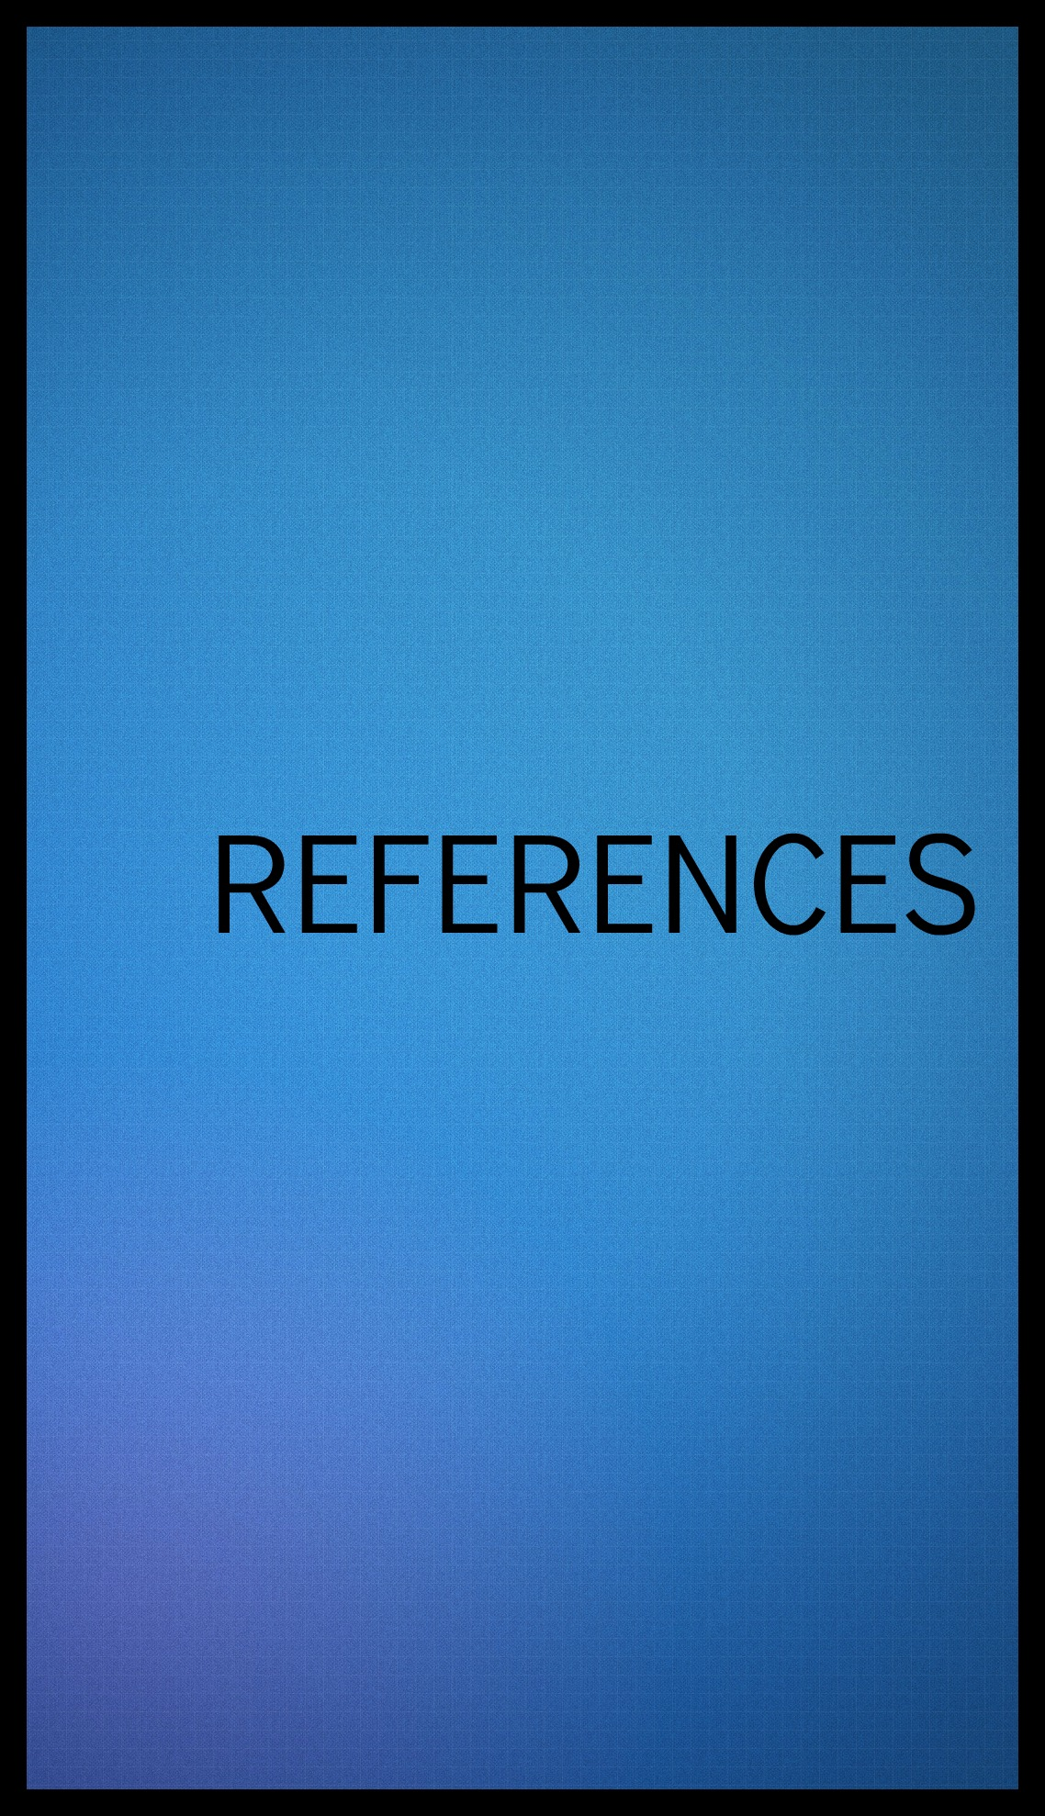

**1. Adcock, R. Alison, Constable, R. Todd, Gore, John C., Goldman-Rakic, Patricia S. (2008, March 28) Functional neuroanatomy of executive processes involved in dual-task performance. Proceedings of the National Academy of Sciences of the United States of America. 97(7), 3567-3572.**

**2. Alsop, Ron (2007, December 4). Taking B-School: Welcoming the new milennials; M.B.A. programs adjust to the next generation, and their parents. Wall Street Journal (Eastern ed.), New York, N.Y., B9.**

**3. Foerde, K., Knowlton, B. J., and Poldrack, R. A. (2006, August). Modulation of competing memory systems by distraction, 103(31), 11778-11783.**

**4.Ophir, E., Nass, C., & Wagner, A. D. (2009, August). Cognitive control in media multitaskers. Proceedings of the National Academy of Sciences, 106(37), 15583-15587.**

**5.Wallis, Claudia. (2006, March 27). The multitaskinggeneration. Time.New York, N.Y. 167(13), 48-56.**

**6.Walus, Yvonne E.. (2008, August). Is multitasking bad for your business? New Zealand Business. 22(7), 30-31.**

**7.Crews, D., & Russ, M. (2010). The impact of multitasking on human and organizational efficiency. Paper presented at the Society for Advancement of Management 2010 International Business Conference, Arlington, VA.**

**8.Freedman, D.H. (2007). What’s next? Taskusinterruptus. New York: MansuetoVenturesLLC.**

**9.Gonzales, V., & Mark, G. (2004). Constant, constant, multitasking craziness: Managing multiple work spheres. Proceedings of CHI, 24-29 April 2004, Vienna, 113-120.**

**10.Lindbeck, A., &Snower, D.J. (2000). Multitask learning and the reorganization of work: From Tayloristic to holistic organization. Journal ofLabor Economics, 18(3), 353-376.**

**11. McCartney, S. (1995). Workplace: The multitasking man: Type A meets technology, Wall Street Journal, 19 April, B1.**

**12. Pashler, H. (2000). Task switching and multitask performance, in Monsell, S., and Driver, J. (Eds), Attention and Performance XVIII: Control of Mental Processes. Cambridge,**

**MA: MIT Press.**

**13.Calvert, S. L. & Wells, J. (2007). Age and gender effects of multitasking on academic performance. Paper presented at the Hawaii International Conference on Education, Honolulu, Hawaii.**

**14.Foehr, U. G. (2006). Media multitasking among American youth: Prevalence, predictors and pairings. Kaiser Family Foundation Report. Menlo Park, CA: Kaiser Family Foundation.**

**15.Hamilton, J. (October 30, 2008). Internal chatter limits multitasking as people age. Morning Edition, NPR. Retrieved from: http://www.npr.org/**

**templates/story/story.php?storyId=96213400**